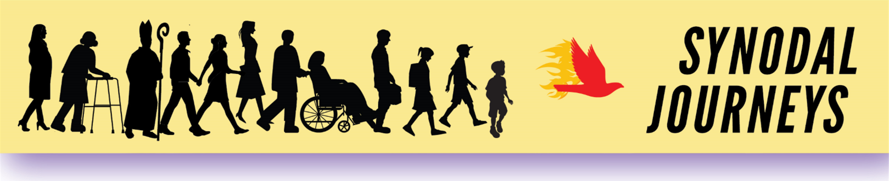
FAQ: What is Synodality?
Why is Synodality important Today? In October 2021, Pope Francis called for the revival of an ancient way of being Church together, called Synodality. It is a way of moving forward that acknowledges that the Church belongs to Christ, that the Spirit is active today, and that all the People of God, together, must prayerfully discern what the Holy Spirit is saying.

What is a “Synod?” A synod is an assembly of church leaders, like the Lutheran Missouri Synod. Eastern and Orthodox Churches have often used synods to discuss and discern important issues. At the end of Vatican II, the participating bishops wished to continue having a voice in global Church affairs, so Pope Paul VI issued a document creating the Synod of Bishops. This Catholic Synod of Bishops meets every few years to discuss selected Church issues. Pope Benedict XVI held a Synod on New Evangelization. Pope Francis has held Synods on the Family, Young People, and the Amazon. Catholic synod gatherings do not have the authority to make binding Church law. Synods issue advisory documents for the Pope to consider.

What is “Synodality?” Synodality comes from the Greek work for “Journeying Together.” It puts the Holy Spirit first, leading the journey. It is based on the belief that the Holy Spirit lives within and speaks to all the baptized Children of God. Before the Church can move forward under the guidance of the Holy Spirit, we must first listen to what the Holy Spirit is saying, especially what the Spirit is saying to those on the margins. This gathering of the Spirit’s voice, from the bishops to the most remote lay person, is called “sensus fidelium” or sense of the faithful (See Catechism #92)

What does Synodality look like? A synodal journey is a process of praying, listening, speaking, discerning, and then finding a way forward. It requires the ability to listen deeply, to sift through what is shared, and then to add the Spirit’s voice as it comes to us in Scripture, Tradition, and the Magisterium. It is a way for every Catholic to have a voice, and to have their issues heard and valued. It is a useful tool for parish pastors, diocesan bishops, and Church leadership at every level, to consult with the Holy Spirit and the People of God before making important decisions.

When was Synodality first used in the Catholic Church? The first recorded use of this process of prayerful listening and discernment took place during the Council of Jerusalem around 50 AD. You can read about it in the Acts of the Apostles, chapter 15 in the New Testament.

What is the “Synod on Synodality?” Pope Francis is convinced that synodality may be the Church’s best path forward into this new millennium. He has called for a “Synod on Synodality” to explore the issue. It will be held in two sessions, October 2023 and October 2024. For more info about Synod 2023-2024, visit https://www.synod.va/en.htm

Permission to reprint for non-profit use. www.pentecostvigilproject.org

